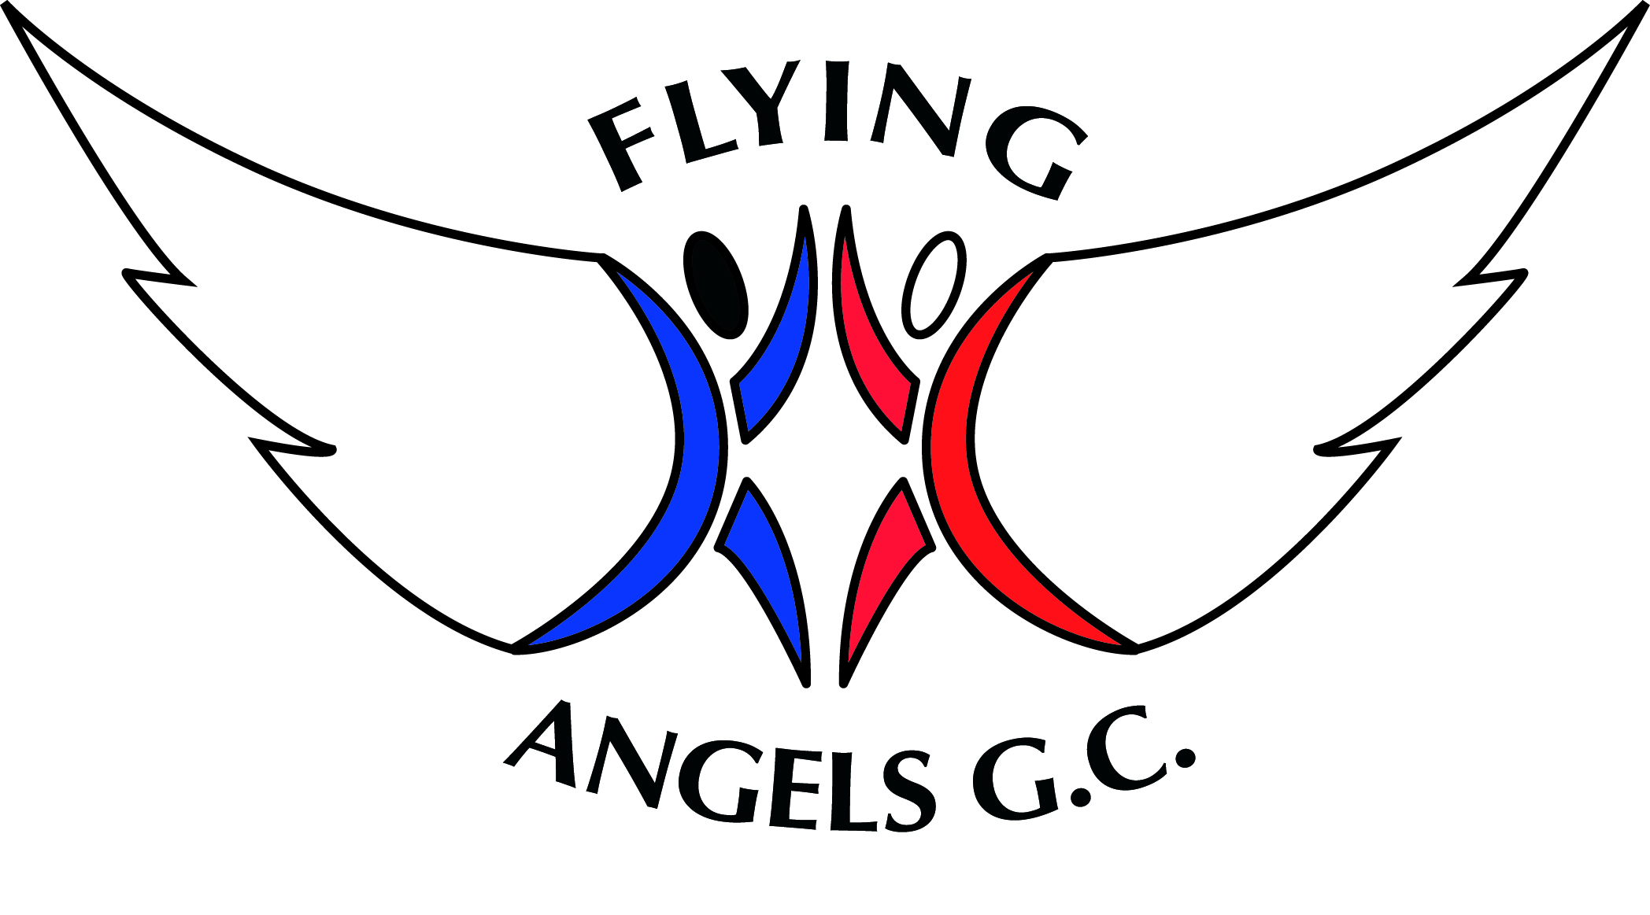

**CODE OF CONDUCT**

Parents and guardians are an integral part of the safe and smooth running of Flying Angels Gymnastics Club. As a parent or guardian, we ask that you:

For Parents / Guardians

* Children are the responsibility of their parents/guardians until handed over to the coach for their session. Please do not leave children unsupervised prior to the start of the session.
* Encourage your child to learn the rules and participate within them.
* Discourage challenging / arguing with officials.
* Where your child is representing at events or competitions, publicly accept officials’ judgements, set a good example by applauding the good performances of all and encourage good sportsmanship.
* Publicly accept officials’ judgements.
* Help your child to recognise good performance, not just results.
* Set a good example by recognising good sportsmanship and applauding the good performances of all.
* Never force your child to take part in sport.
* Always ensure your child is dressed appropriately for the activity and has plenty to drink.
* Keep the club informed if your child is ill or unable to attend sessions.
* Endeavour to establish good communications with the club, coaches and officials for the benefit of all.
* Share any concerns or complaints about any aspect of the club through the approved channels with the coach, Club Manager or the Club Welfare Officer (details on the main notice board).
* Always come into the waiting room to collect your child promptly at the end of each session. Children will be handed back by a coach at the end of the session. If you want your child to make their own way home, and your written consent must have been received or acknowledged via email by the Club Manager. In n circumstances will a child be allowed to leave alone.
* Behave respectfully to coaches, gymnasts and other parents always using correct and proper language.
* Never punish or belittle a child for poor performance or making mistakes
* Always collect your child promptly at the end of a session
* Support your child’s involvement and help them to enjoy their sport
* Never take photos or videos during training without the consent of the Head Coach. All photos and recorded images must only be for personal use and cannot be shared on social media without the consent of all parents of gymnasts who feature in the photo.
* Please do not enter the gym unless specifically requested to do so by the coach.
* Please leave the spectator areas clean and tidy.
* Please avoid any behaviour that could be perceived as intimidating. This includes threatening, bullying and bringing the club or its coaches into disrepute.