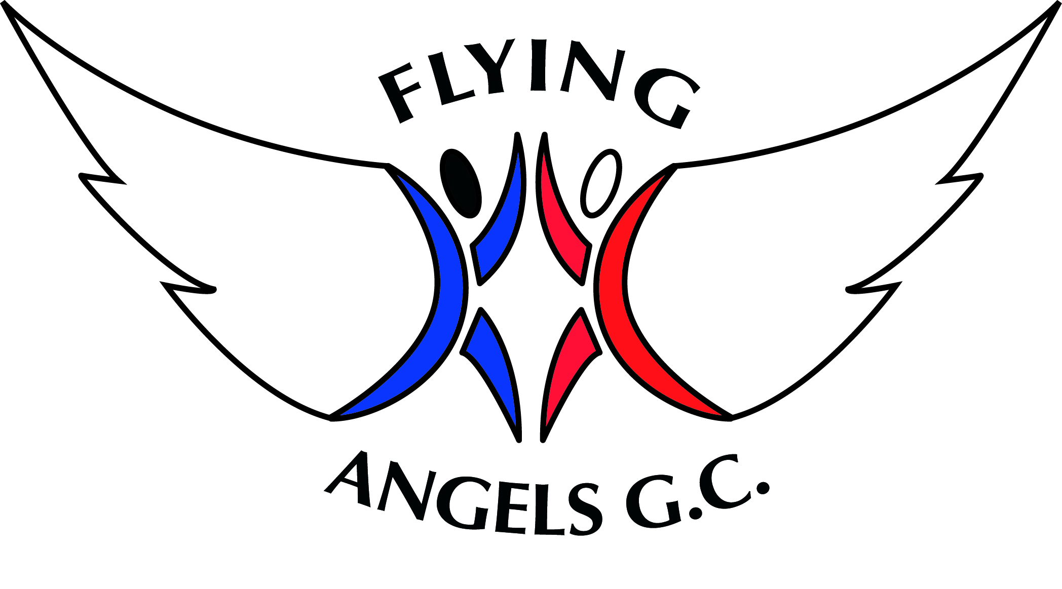
Proficiency Awards Individual Charts | Gymnast Name:

8 |  | 7 |  | 6 |  | 5
Run on the spot for 30 seconds |  | Run freely for 45 seconds |  | Follow my leader in pairs using different actions for 1 minute |  | Leap from 1 foot to the other
Shapes tuck, pike, straddle sitting and star & stretch |  | Bent leg dish |  | Dish and arch |  | Japana to 45°
Front and back support |  | Back support raising 1 leg at a time toward the vertical |  | Press up forwards and  backwards |  | Move sideways from dish to arch
Jump I and out of a hoop |  | Stand and jump to safe landing |  | Hop jump, hop jump along the floor |  | Hop, step and jump
Transfer weight from one foot to the other |  | 1 foot balance on bench or box top |  | Piked V-sit with hand support |  | T-balance
From crouch, bunny hop |  | From front support jump in and out |  | Travelling bunny jumps |  | Bunny jumps over a bench from side to side
Rock backwards and forwards in tuck |  | Rock backwards and forwards in pike and straddle |  | Rock backwards and forwards tucked to stand |  | Tucked forward roll down an incline
Matched and mirrored sequence of arm movements |  | Front and back support, lower to the floor with control |  | Side support on 1 arm, turn slowly to the other |  | Front support with partner
Ribbons Explore patterns using or scarves |  | Bounce and catch a ball 3 times |  | With a partner, roll and catch a ball or hoop |  | Roll a ball or hoop, travel at its side and pick it up
Walk forwards along a bench on tiptoes |  | Walk forwards along a bench and full turn in the middle |  | Walk backwards along a bench and full turn in the middle |  | Run, hurdle step and 2 footed rebound
Passed Date |  | Passed Date |  | Passed Date |  | Passed Date
Coach Signature |  | Coach Signature |  | Coach Signature |  | Coach Signature
Proficiency Awards Individual Charts | Gymnast Name:
.
4 |  | 3 |  | 2 |  | 1
Skip for 30 seconds |  | Skip for 45 seconds |  | 6 shuttle runs |  | 10 shuttle runs
Low lunges with both legs – forwards and sideways |  | Japana flat |  | Bridge |  | Splits
Shoulder stand with hips supported |  | Headstand with knees bent and lower into frog |  | Half lever with 1 foot only raised change legs |  | Half lever or straddled half lever
Cat leaps 2 times, each leg |  | Tuck jump |  | Jump half turn |  | Jump full turn
Frog balance |  | Headstand with knees bent |  | Headstand |  | Moving toward handstand using apparatus
Straddle bunny jumps across a bench side-to-side |  | Cartwheel |  | Cartwheel quarter turn off a bench |  | Change leg handstand
Tucked backward roll down an incline |  | Forward roll |  | Backward roll |  | Handstand forward roll
Chassis steps with arm swing facing a partner |  | Teddy bear roll – back to back with partner |  | Counterbalance |  | Matched and mirrored sequence – to include roll, jump and balance
Hoola hooping |  | Throw, jump and catch hand apparatus |  | Single knee balance, throw and catch apparatus |  | Throw hand apparatus, perform a leap, catch and perform a balance
From box top – star jump to safe landing |  | Squat on box top and stretch jump off |  | Squat on box top and tuck jump off |  | Straddle on box top and straddle jump off
Passed Date |  | Passed Date |  | Passed Date |  | Passed Date
Coach Signature |  | Coach Signature |  | Coach Signature |  | Coach Signature

