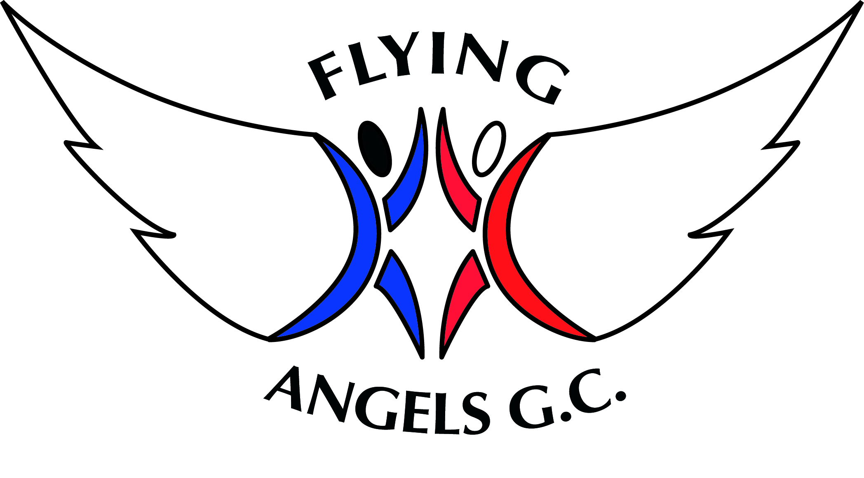

CODE OF CONDUCT

For Participants

We are fully committed to safeguarding and promoting the well-being of all our members. The club believes it is important that members, coaches, administrators and parents associated with the club should, at all times, show respect and understanding for the safety and welfare of others. Therefore, members are encouraged to be open at all times and share any concerns or complaints that they may have about any aspect of the club with Sue (Welfare Officer).

As a member of Flying Angels Gymnastics Club you are expected to abide by the following club rules:

- All members must participate within the rules and respect coaches, judges and their decisions

- All members must respect opponents and fellow club members

- Members should keep to agreed timings for training and competitions or inform their coach, or if they are going to be late

- Members must wear suitable attire for training and events as agreed with the coach. Keep all long hair tied back. Remove all body jewellery

- Members must pay any fees for training or events promptly

- Members must not smoke, consume alcohol or take drugs of any kind whilst representing the club at competitions or other events

- Members should treat all equipment with respect

- Members must inform the head coach of any injuries or illness they may have before the warm-up begins

- Members should not eat or chew gum during a session

- Members must not use bad language

- Members should remain with coaches at the end of a session until collected by their parent or guardian

