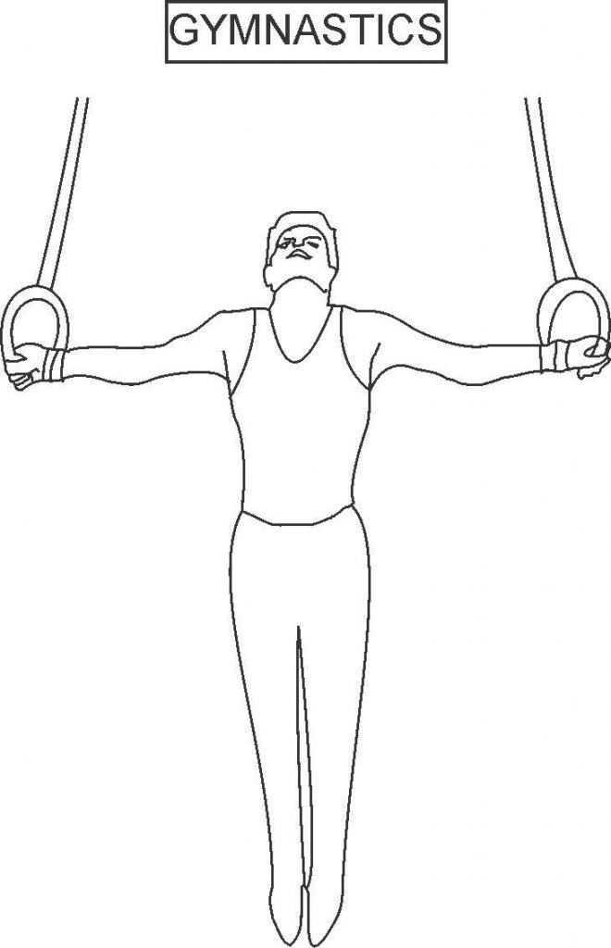

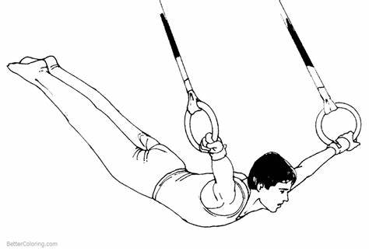

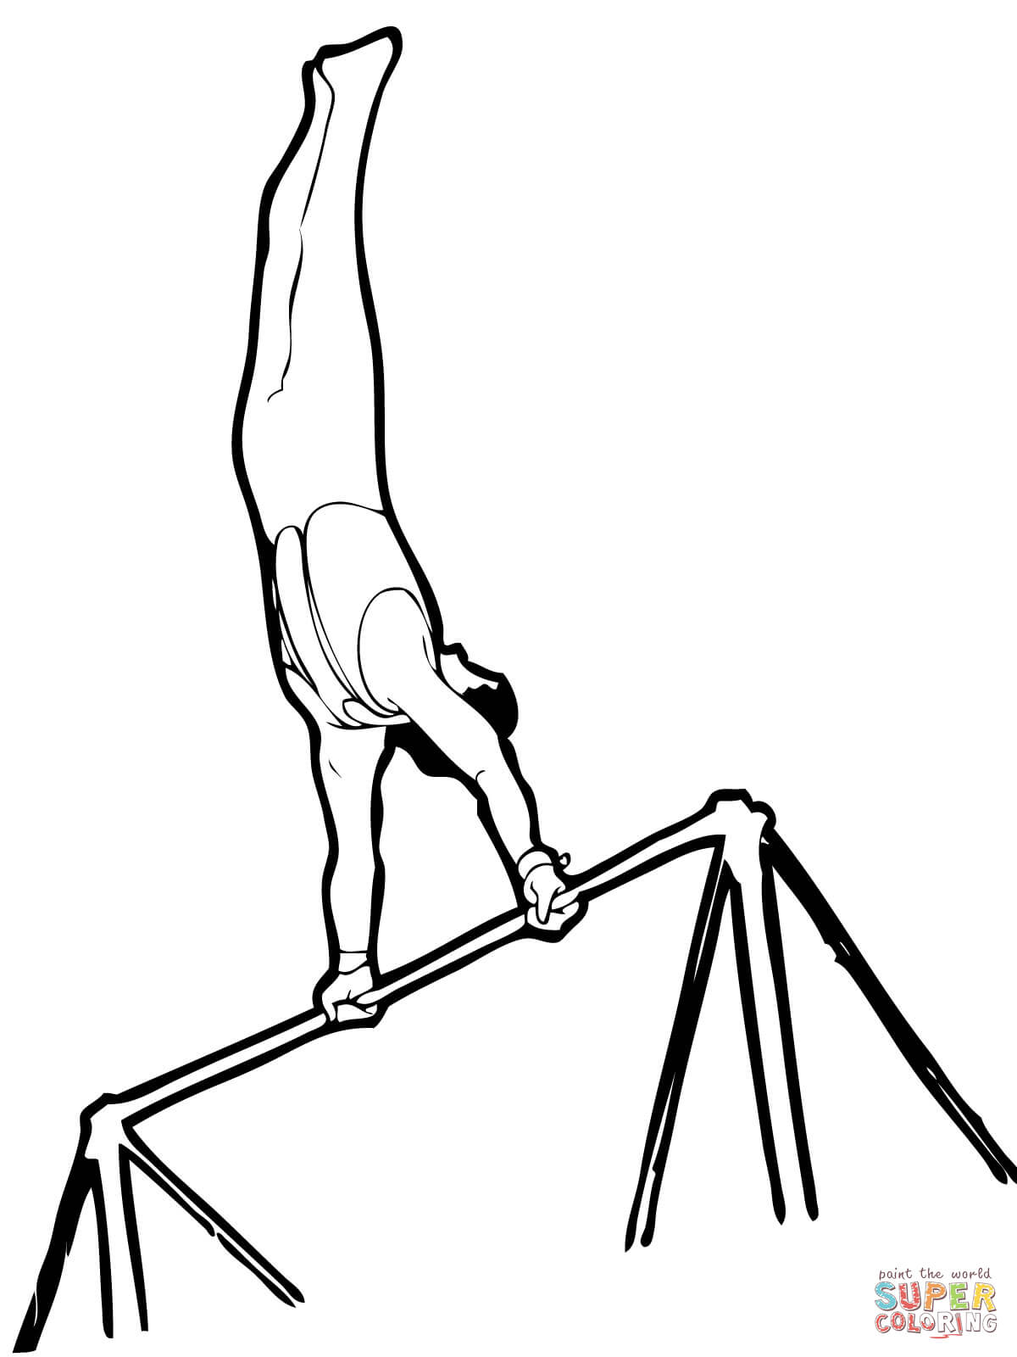

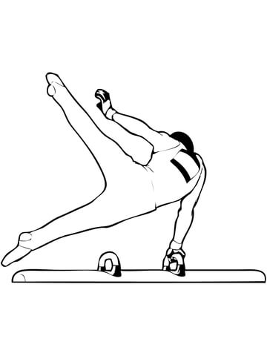

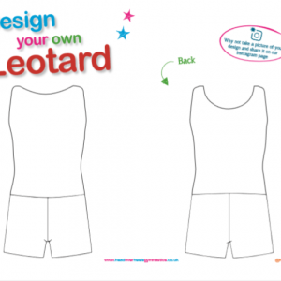

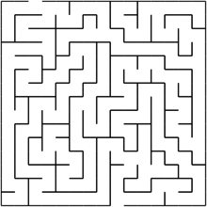

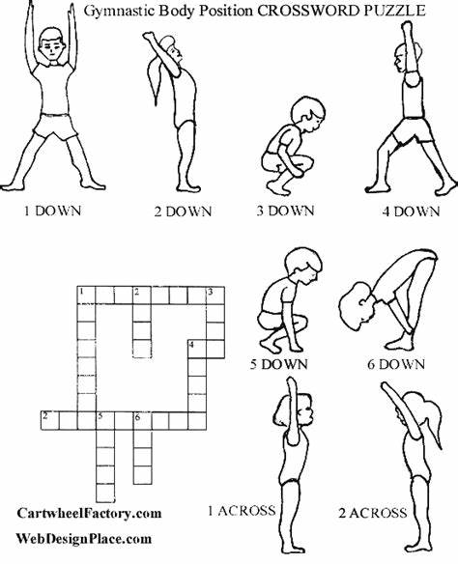

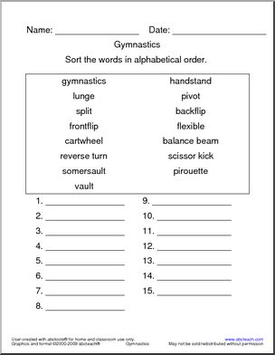

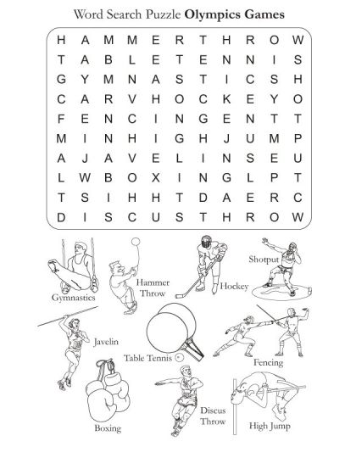

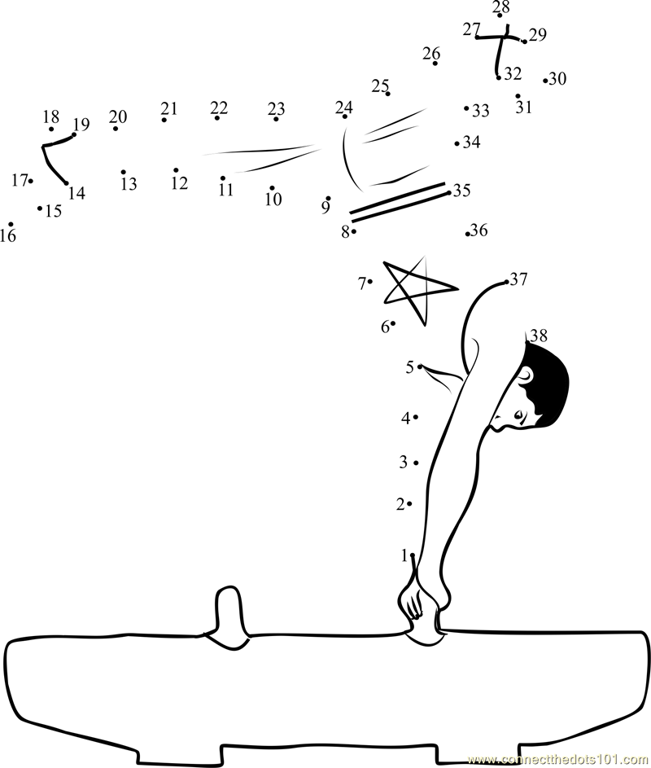

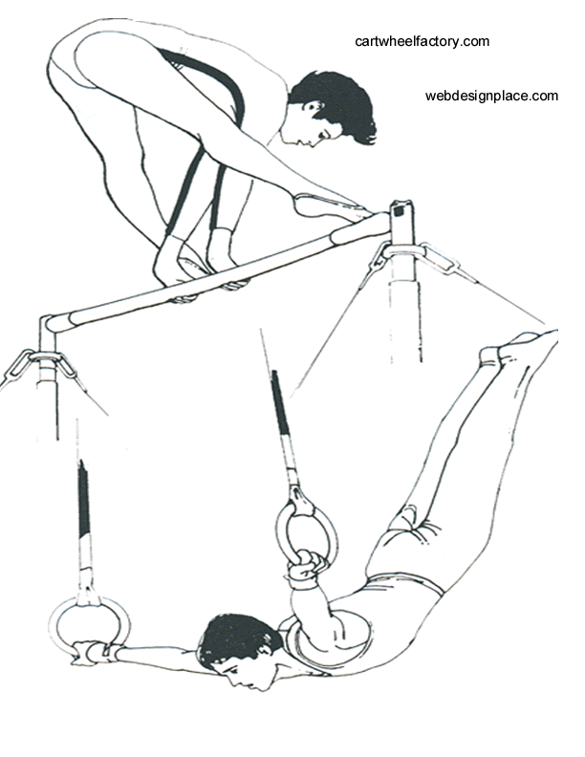

Gymnastics Word Search
W | F | S | G | N | E | J | O | P | D | W | Z | F | L | P | G | R | Z | L | M
L | L | D | D | P | M | D | U | C | I | F | G | Y | A | V | S | L | N | X | T
F | T | L | T | F | I | N | I | S | H | U | R | X | E | O | U | Y | K | S | A
D | D | Z | D | T | E | T | J | L | X | N | F | N | K | G | K | I | S | E | R
E | R | E | Z | G | G | U | L | V | K | N | P | O | I | K | B | D | D | G | G
G | D | P | I | K | L | C | D | J | C | G | O | I | P | E | J | B | N | N | L
N | N | W | S | S | E | K | C | Z | I | A | U | S | R | Y | B | J | A | U | L
O | S | G | R | V | E | M | F | A | T | E | E | N | N | E | X | T | T | L | B
R | T | B | A | M | H | M | K | S | S | Z | S | E | W | A | U | C | S | L | O
T | R | G | B | M | W | T | O | F | K | D | Y | M | N | K | B | V | D | A | U
S | A | C | U | I | T | T | P | C | V | Z | O | I | M | U | N | B | N | A | A
V | M | T | L | D | R | I | M | N | S | Z | S | D | G | X | M | W | A | B | C
R | P | D | V | Z | A | L | Y | R | F | U | Z | I | O | U | X | G | H | G | B
K | O | O | W | X | C | P | W | V | C | X | O | Y | H | Q | Y | Y | G | J | E
C | L | Q | W | X | S | S | N | Y | E | E | P | N | W | X | T | M | F | R | C
U | I | K | W | C | Q | B | R | G | J | J | M | E | K | Z | E | N | B | C | N
W | N | R | L | Q | C | M | B | U | E | T | J | L | W | B | F | A | R | B | A
K | E | P | A | S | C | R | J | X | L | Q | L | D | R | W | A | S | K | C | L
I | N | S | V | B | I | C | M | S | B | M | S | D | Z | B | S | T | L | X | A
A | K | L | D | A | O | T | N | P | M | C | D | A | Z | B | V | I | V | E | B
N | P | N | Q | A | U | L | A | J | U | P | H | R | Y | X | N | C | K | N | N
O | I | M | N | H | Y | L | J | W | T | O | C | T | C | U | B | S | X | D | V
T | R | T | J | P | V | O | T | F | J | O | I | S | H | R | D | K | Z | K | W

Tuck | Pike | Straddle | Stick | Finish
Safety | Gymnastics | Balance | Strong | Split
Next | Dimension | Cartwheel | Handstand | Lunge
Vault | Bars | Trampoline | Tumble | Fun

Gymnastics Word Search
D | E | P | I | K | E | U | S | P | R | I | N | G | B | O | A | R | D
G | T | U | C | K | N | G | Y | M | N | A | S | T | I | C | S | A | I
S | A | F | E | T | Y | O | L | I | L | F | N | Z | E | M | A | E | B
P | G | N | I | R | P | S | D | N | A | H | T | N | O | R | F | E | E
B | O | R | D | K | E | P | F | L | V | A | U | L | T | D | I | E | N
A | O | L | E | O | S | I | D | Y | U | I | F | L | I | P | R | N | N
C | O | F | F | H | U | A | S | O | U | A | I | T | R | I | P | L | E
K | E | S | L | A | C | B | F | O | U | R | I | N | C | H | E | R | T
H | A | U | C | O | L | N | L | R | D | B | C | N | X | E | L | F | A
A | T | N | S | F | O | E | I | E | A | O | L | H | P | D | E | M | I
N | S | G | E | T | V | R | O | T | G | Y | N | E | E | W | U | E | A
D | U | J | Y | E | I | A | A | T | H | A | A | H | F | N | B | K | T
S | K | L | E | M | B | N | T | U | A | G | L | I | E | R | K | E | T
P | A | E | Z | E | N | W | G | S | U | R | I | I | V | C | O | O | J
R | H | D | Z | I | I | A | R | M | I | P | D | E | T | E | H | N | R
I | A | D | O | S | U | A | S | D | A | L | A | Y | O | U | T | A | T
N | R | E | T | R | B | V | E | T | A | T | O | N | Z | F | U | L | L
G | A | E | C | P | O | I | N | T | T | E | N | O | E | P | J | M | F

- Back handspring
- Bars
- Beam
- Demi
- Double
- Double Front
- Eight Incher
- Flex
- Flip
- Floor
- Flop
- Four Incher
- Front handspring
- Full
- Gymnast
- Gymnastics
- Layout
- Leotard
- Pike
- Point
- Safety
- Springboard
- Stingmat
- Ten O
- Triple
- Tsukahara
- Tuck
- Twist
- Vault
- Yurchenko

