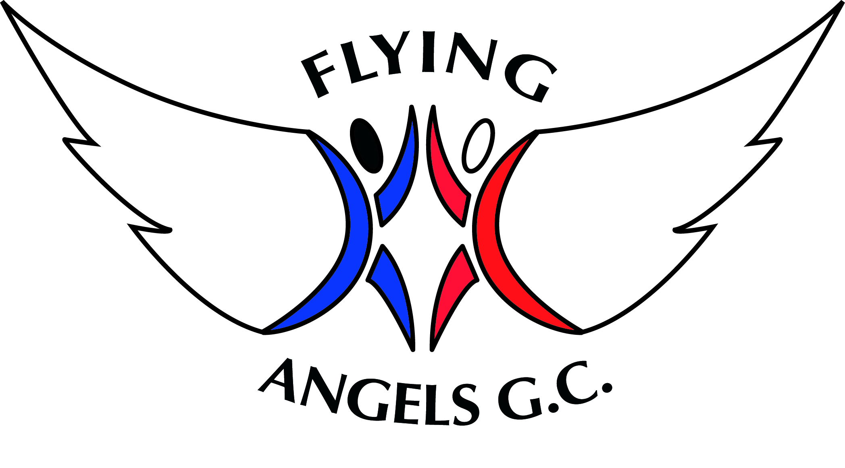
CODE OF CONDUCT

For Parents / Guardians

- Encourage your child to learn the rules and participate within them

- Discourage challenging / arguing with officials

- Publicly accept officials’ judgements

- Help your child to recognise good performance, not just results

- Set a good example by recognising good sportsmanship and applauding the good performances of all

- Never force your child to take part in sport

- Always ensure your child is dressed appropriately for the activity and has plenty to drink

- Keep the club informed if your child is ill or unable to attend sessions

- Endeavour to establish good communications with the club, coaches and officials for the benefit of all

- Share any concerns or complaints about any aspect of the club through the approved channels

- Use correct and proper language at all times

- Never punish or belittle a child for poor performance or making mistakes

- Always collect your child promptly at the end of a session

- Support your child’s involvement and help them to enjoy their sport

